
RE: School Therapy Dog
Dear Families.
We are excited to introduce you to a new member of the St John’s and St Peter’s CE Academy team. Lucca is a 5-month-old Goldendoodle who, with support from the staff and PAWs Therapy Dog Team, is in training to become our school dog and is set to become an integral part of our school family.
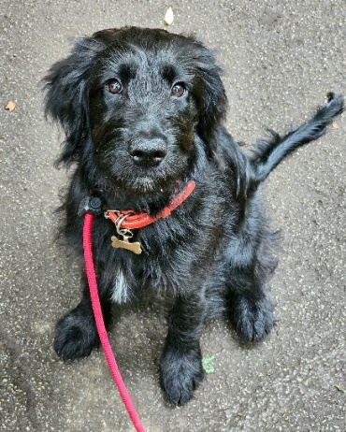
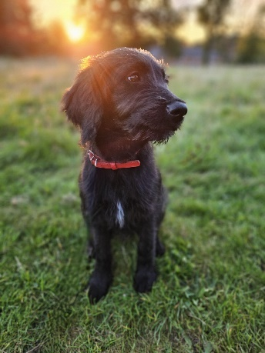
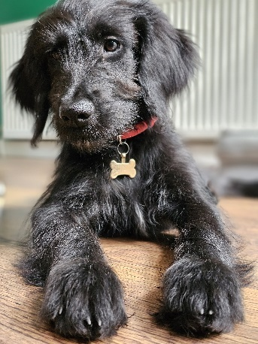
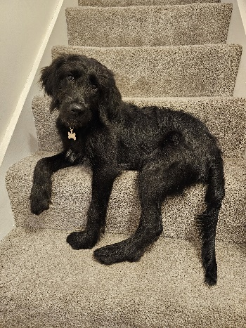

What are the benefits of having a school dog?
Numerous research studies have shown the benefits of therapy dogs in schools. Therapy dogs have been working in schools for the past 5 years across the UK. However, they have been commonplace in schools in the USA and Australia for many years.
Evidence indicates that benefits include:
- Cognitive – companionship with a dog stimulates memory, problem-solving and game-playing. Encouraging expression, participation and shared attention.
- Social – a dog provides a positive mutual topic for discussion, encourages responsibility, wellbeing and focused interaction with others. Encouraging respect and thereby improving students’ relationships with each other, parents and teachers. https://www.bbc.co.uk/news/education-47655600
- Emotional – a school dog improves self-esteem, acceptance from others and lifts mood, often provoking laughter and fun. Dogs can also teach compassion and respect for other living things as well as relieving anxiety. Improved behaviour, attendance and concentration, reduced stress and improved self-esteem.
- Physical – interaction with animals reduces blood pressure, provides tactile stimulation, gives motivation to move and stimulates the senses.
- Environmental – a dog in a school increases the sense of a family environment, with all of the above benefits continuing long after the school day is over.

Of course, bringing any animal into our school is not something we have taken lightly, both for the animal’s sake and for the sake of the students and adults in the school. We have discussed the practicalities, including everything from risk assessments and insurance to dealing with training, dog toileting and students’ allergies. Children will never be left alone with the dog, and they will be taught how to be around a dog before it is in a classroom environment.
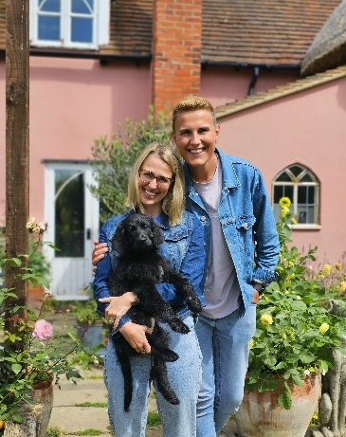
Meet the dog!
Lucca is a Goldendoodle puppy and is currently 5 months old. Golden Doodles are known to be hypoallergenic dogs, holding the qualities of their Golden Retriever and Poodle parents making them well-trainable, caring, sociable dogs. The breed has been carefully selected because of its ideal temperament and because it is used widely in the field of therapy and support (e.g. guide dogs).
Lucca joined Mr Bateson’s family during the 6 week’s holiday and has already made a big impression. She is very friendly and loves to play fetch. She is learning incredibly fast, and Mr Bateson is working hard to ensure she is well-trained for being around children and in a working environment.

The dog’s role
For the first few months, Lucca will be coming to school on a part time basis. This is to help her acclimatise and not be overwhelmed meeting too many people. Lucca will spend the first few months in and around the school, mainly in staff areas to build socialisation. When around the building, Lucca will always be on a short lead and accompanied by a member of staff.
Our goal for Lucca is to become a Professionally Accredited Therapy Dog. This is a working dog role, not just a school pet. This type of training relies heavily on the Lucca’s temperament and training, which we will help develop over the next few months as she grows from puppy to adulthood. Lucca has already been screened by a member of the PAWs team, and they believe she is a suitable candidate for therapy training. Lucca will be “in training” for the rest of this academic year until she is a mature adult. On her 1st Birthday in May 2024, she will become a PAWs Accredited Working Therapy Dog, provided she passes their strict assessment.
While Lucca’s main place of residence will be in the Senior Leadership Office, children will be able to interact with her under strict supervision. Please understand that we will do everything we can to reassure children who are fearful and that under no circumstances will they be forced to meet with Lucca. Whilst we are at an early stage in this process, it would be helpful to know whether we have any students who are allergic to dog hair or who have a particular phobia concerning dogs. If we do not hear from you, we will assume you are happy for your child to eventually interact with the dog.
We hope the children will gain a great deal of enjoyment from having a school dog and that she becomes an established part of life at St John’s and St Peter’s family. We understand that it is not possible for all families to have a family dog and therefore we hope that this is an opportunity for children to share in a dog and gain from a relationship and contact on a regular basis. We hope you will join us in welcoming Lucca to the St John’s family and embrace all that she has to offer the school and community. If you have any questions, queries or worries, please speak to a member of the leadership team.
Yours sincerely,

Mr Bateson
Interim Deputy Head of School

